Order No: 73 of 2025
Dated: 02-09-2025

Subject: Assignment of Responsibilities for Handling Institutional Litigations and Right to Information (RTI).

To ensure efficient management and oversight of all legal matters, litigations, and Right to Information (RTI) requests pertaining to the institution, the following assignments are hereby made with immediate effect:
- Mr. Bilal Ahmad Bhat, Head of Department (HoD), Leather Technology Department, is designated as the primary officer responsible for looking after and managing all litigations and RTI matters of the institution. He shall coordinate with relevant legal advisors, monitor ongoing cases and RTI requests, prepare necessary documentation, ensure timely responses to RTI queries, and report progress to the undersigned on a regular basis.
- Mr. Hamid Ali, Multi-Tasking Staff (MTS), is assigned to assist Mr. Bilal Ahmad Bhat in the aforementioned duties. His responsibilities shall include providing administrative support, maintaining records for both litigations and RTI matters, and facilitating communications as required.
This order shall remain in force until further notice or modification.

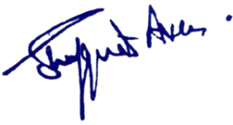

No:KGP/Estt/2025/968
Dated:02-09-2025
Dr. Shafquat Ara
Principal
Kashmir Govt.Polytechnic College Srinagar

.

